
ImmsBC Appointment Booking & Clinic Management Training Guide
January 9, 2023
Contents

Creating Appointments 2
Calculating Capacity per block 2
Creating Appointments in ImmsBC 3
Custom Blocks 8
Notify Communications 11
Edit Appointments 12
Without Custom Blocks 12
Deleting a Clinic Day 14
With booked appointments 14
With no booked appointments 15
Clinic Management 16
Creating New Clinics in ImmsBC 16
Activate/Deactivate a clinic 16
Don’t show on Citizen Portal 16
Add/Remove Clinic Attributes 17
Activate/Inactivate Supply Locations 18
Support 19

Creating Appointments

Calculating Capacity per block
Before creating appointments in ImmsBC, you will need the following information from the vaccination clinic leader to calculate the Capacity per Block:
- If calculating based on known vaccine allocations
  - Total Appointments
  - Number of public hours open
  - Duration Per Block (always 15 minute increments = 4 blocks/hour)
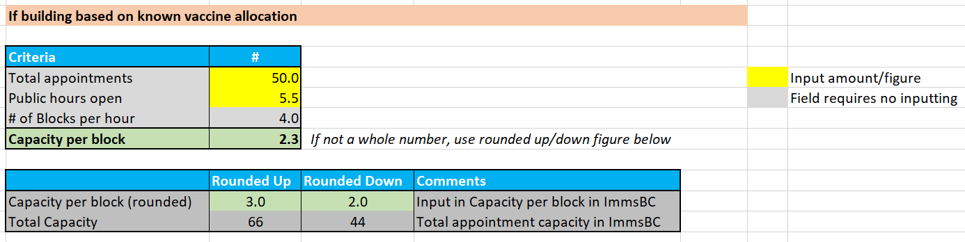

To calculate the Capacity per Block, use the ImmsBC Appt Calculator. It will assist in calculating the exact number to input into ImmsBC. (If you already know the capacity per block, you can bypass this step and directly create appointments in ImmsBC)
Depending on the calculations, if the capacity per block is not a whole number, you may need to use the rounded up or down calculations for Capacity per Block which will update the Total Capacity for that day. In the example above 50 appointments does not provide a whole number, therefore we can either round down to 44 appointments (2 appointments per block) or round up to 66 appointments (3 appointments per block).

Creating Appointments in ImmsBC
- Login into ImmsBC
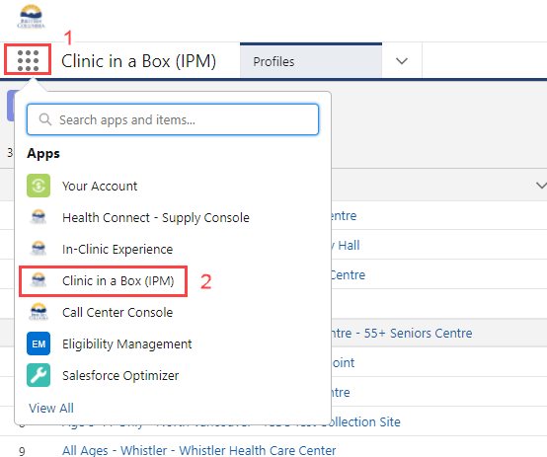
- Click on the Clinic in a Box (IPM) found at the top left corner. Select Clinic in a Box (IPM) from the dropdown list.

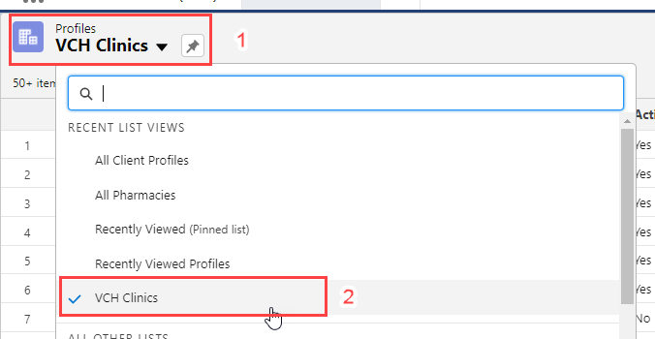
- Under Profiles, select the drop-down arrow and filter for VCH Clinics.

- Search by entering the Clinic’s name in the search engine box found at the top right corner. Click on the clinic to open it. Ensure you are selecting the correct clinic & age cohort.

- Click on the Scheduler tab, and filter to BC Immunization Program

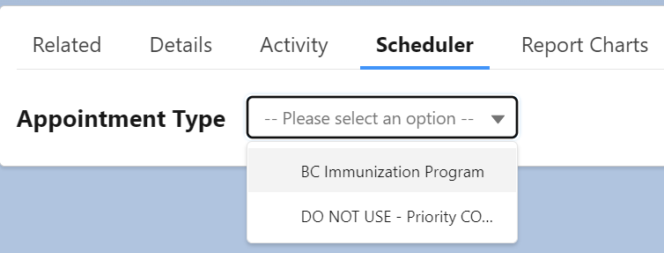

- For this example, here are the clinic details:
  - May 13, 14 & 15, 2022
  - 120 appointments per day
  - Clinic Hours:
    - Clinic start time: 1030
    - Clinic end time: 1630
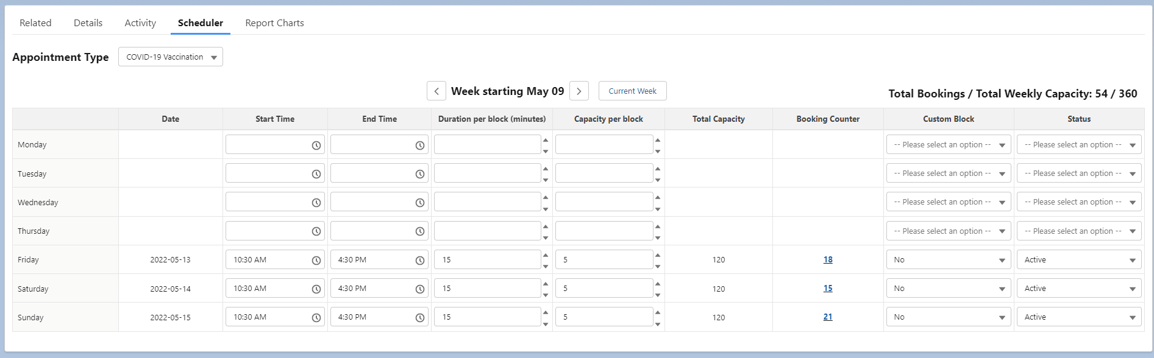
  - Duration per block: always 15 minutes (4 blocks per hour)
Before you start, make sure that you are booking on the correct day of the week. The date will only show after any changes are saved.

Field | Comment
Start Time | Input desired clinic start time
End Time | Input desired clinic end time
Duration per block (minutes) | Always 15 minutes
Capacity per block | Input value calculated in the ImmsBC Appt Calculator
Custom block | If no custom adjustment needed, select No. If custom required (i.e. lunch break), select Yes. See below section on Custom Blocks if adjustment is required
Status | There are 5 status options, but only 2 are relevant.  - Active: Will activate clinic appointments & will be available for the general public to book  - Inactive: Will create the clinic day, but WILL NOT be available to book by the general public – clinic days can be created in the system ahead of time using the Inactive status and then make the day active when closer to the day. When building new clinic days you can also set to Inactive to begin with, double-check that what you have created is correct, and then turn the day to Active.
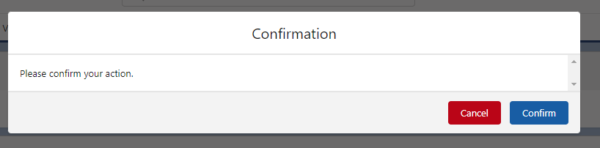
- After inputting the information, click on save at the bottom right. Click on confirm.

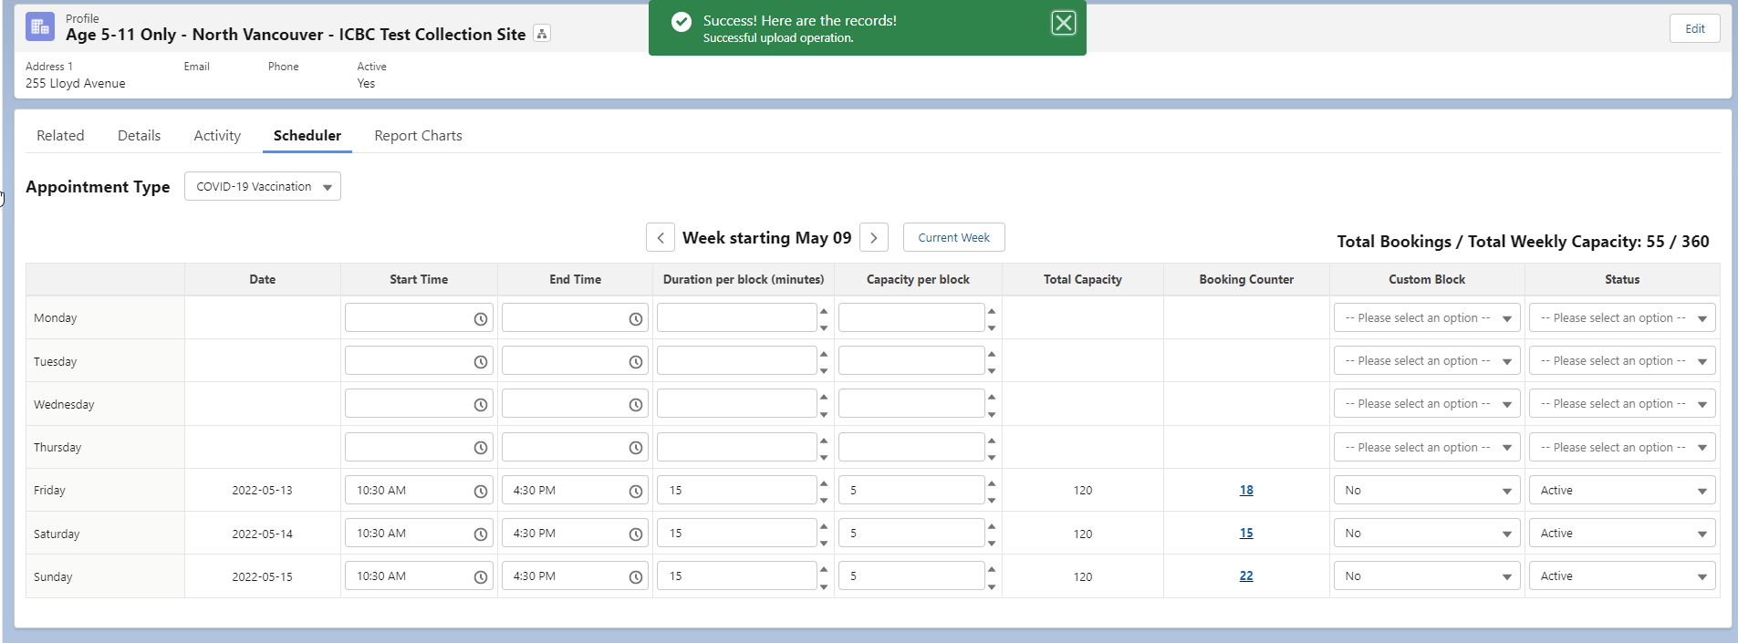
- Once the confirm button is selected, the Date, Total Capacity & Booking Counter columns will populate.

Custom Blocks
When you have a clinic day that needs to reflect staff breaks, increased/decreased intake during certain time frames, or any other special scheduling, it is necessary to use the custom block functionality. For example:
- May 24, 2022
- 115 appointments
- Clinic Hours:
    - Clinic start time: 1030
1030-1230 / 1300-1500 = 4 hours
    - Clinic end time: 1500
    - Break from 1230-1300
- Duration per block: always 15 minutes (4 slots per hour)
Here is how to schedule using a custom block:
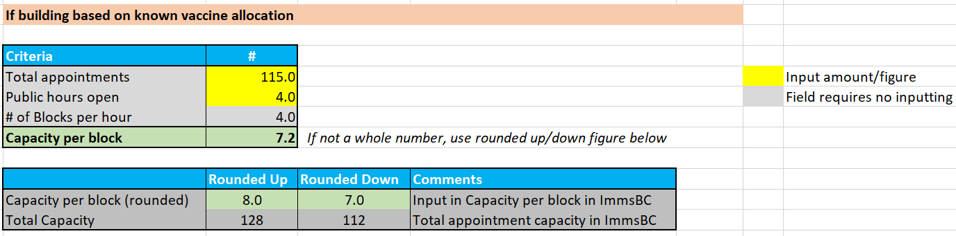
- Use the ImmsBC Appointment calculator to calculate the capacity per block. Enter the total hours open (ensure you are deducting any breaks when the clinic is not open). In the above example, the clinic will be open for a total of 4 hours.

- Find the desired day and enter the Start time, End time and Duration per block (always 15). Then input the capacity per block by using the rounded up, or rounded down figure from the calculator. (Use the figure that is the closest to the total appointments required). Set Custom Block to Yes and Status as Inactive.
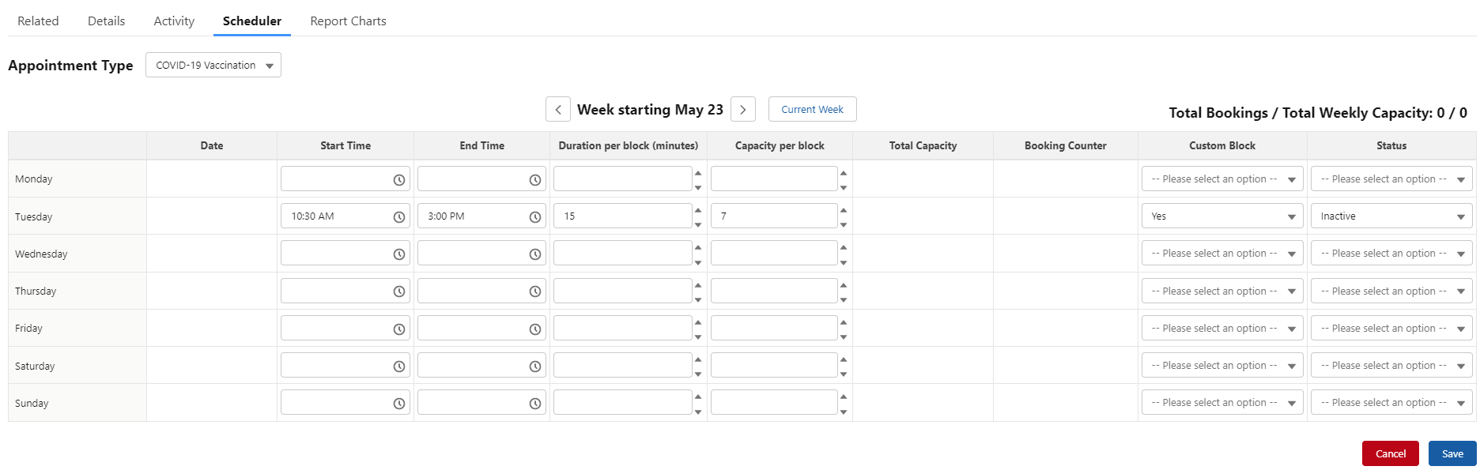

- Click on Save, and confirm your action
- You will now have more appointments than necessary, and you will need to edit the schedule to reflect the desired break(s).
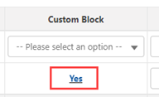
- Click Yes under the Custom Block column

- Under the custom block, go to the time frame(s) where there is/are a break and no appointments should be booked. In our example, we wanted no appointments from 12:30 to 13:00. For these time frames, change the Capacity per block to 0 and Status to Inactive. This means there will be no appointments during that specified time frame. 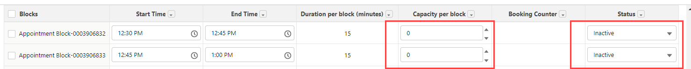

- Save, and verify that there are no appointments during this timeframe. Since we rounded down to 7, this provides us with a total capacity of 112 appointments.

In the event, that we want exactly 115 appointments:
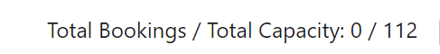
- Since we want to schedule 115 appointments, and the total is now at 112, we will need to add 3 more appointments during the day. Spread out the appointments during the day to avoid a surge of citizens during a timeframe. Click save, and the total number of appointments should be reflected.
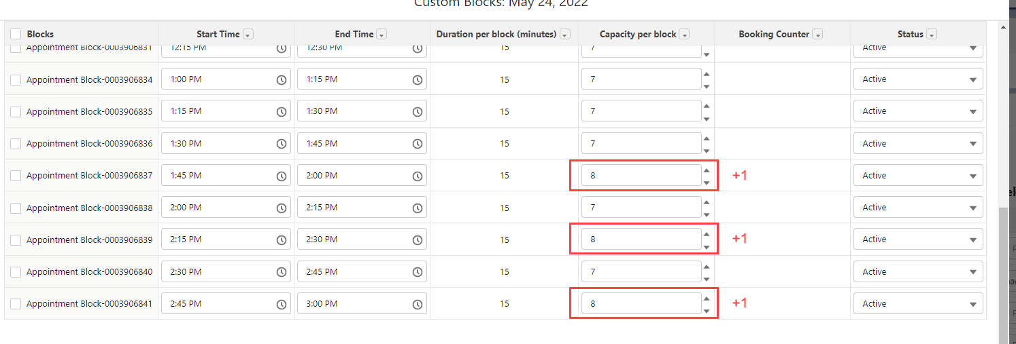
Before:

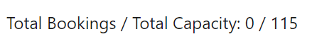
After:
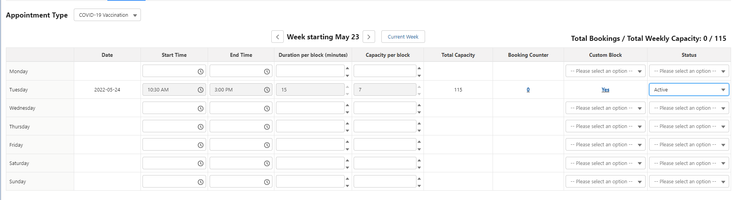

- Once the custom block has been created and the clinic looks accurate, change the status to Active.

Notify Communications
Once appointments have been set to active, email WebUpdates@vch.ca the following information to update the VCH COVID-19 Vaccine page and cc Esther.Sigurdson@vch.ca; Jagdeep.Gill@vch.ca; Andrew.Reyes@vch.ca; mahsia.azizi@vch.ca
- Clinic name as per ImmsBC
- Address
- Age range
- Clinic dates and times including breaks
  - E.g. if there is a lunch break from 12-1pm, the hours of operation would be “9 a.m. to 12 p.m. and 1 p.m. to 4 p.m.”

Edit Appointments

Without Custom Blocks
In the event that a clinic requires more or less appointments and no custom block(s) are required, you will only need to adjust the Capacity per Block column.
Scenarios where this would work:
- Increasing appointments for the day (i.e. current capacity block is 5 and increasing to anything greater than 5)
- Decreasing appointments ONLY IF no blocks are already at capacity (i.e. current capacity block is 5 and we want to decrease to 3 and no blocks are booked over 3)
If your scenario is one of the above, take the following steps to make changes:
- Find the desired clinic name
- Click on the Scheduler tab
- Find the desired clinic day(s) that require an increase/decrease in appointments
- Adjust the Capacity per block field as desired
- Save your changes
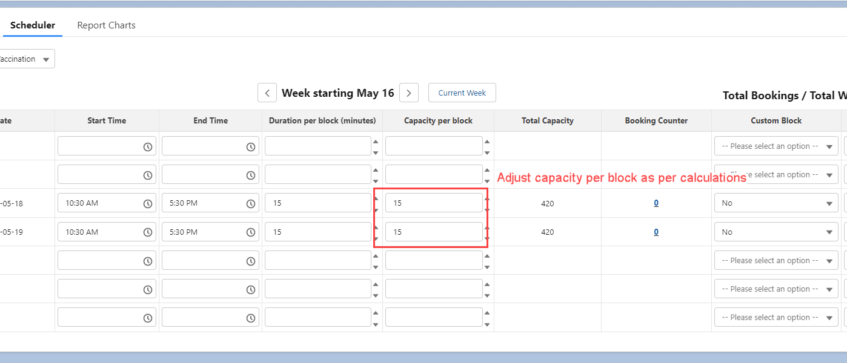
If some blocks are at capacity, please change custom blocks to YES and follow instructions in the next section.

With Custom Blocks
If you need to edit a scheduled appointment day that has a custom block or decrease appointments that already are over the desired capacity, you will need to adjust each block individually.
To adjust, click Yes under the Custom Block column. Adjust the capacity per block for the relevant appointment block(s), and then Save. The new Total Capacity should be updated.

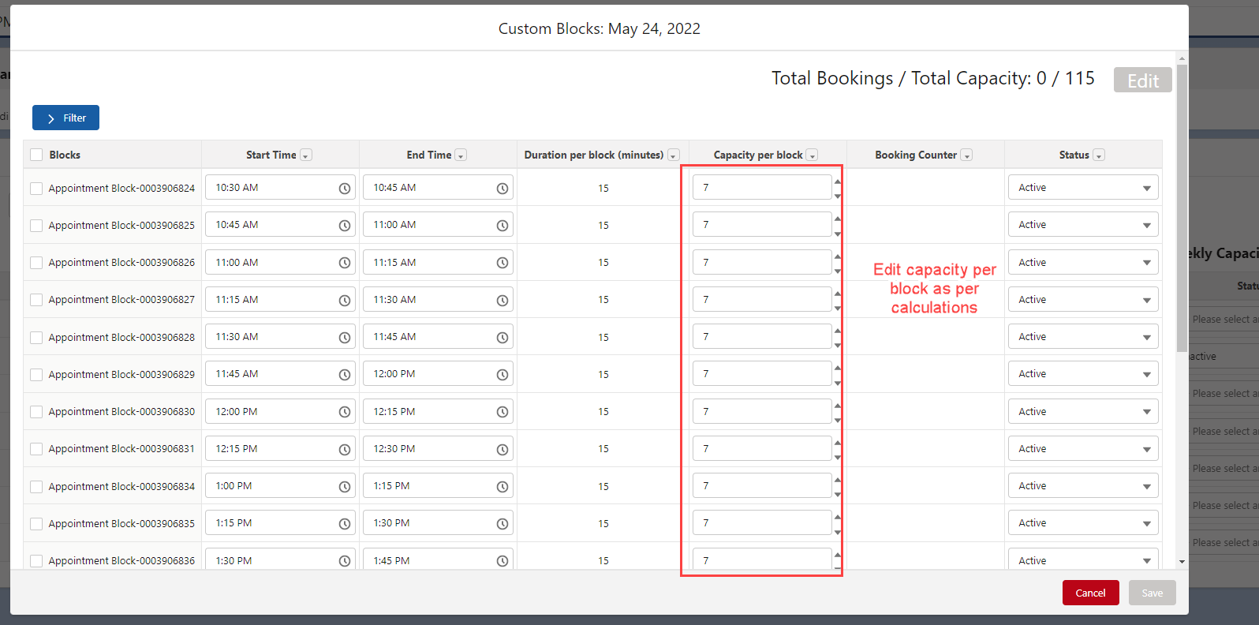

Deleting a Clinic Day

With booked appointments

If clinic needs to be cancelled and there are booked appointments:
- Set the status to inactive to prevent more clients from booking appointments.
- Click on the number of appointments on under the booking counter column.
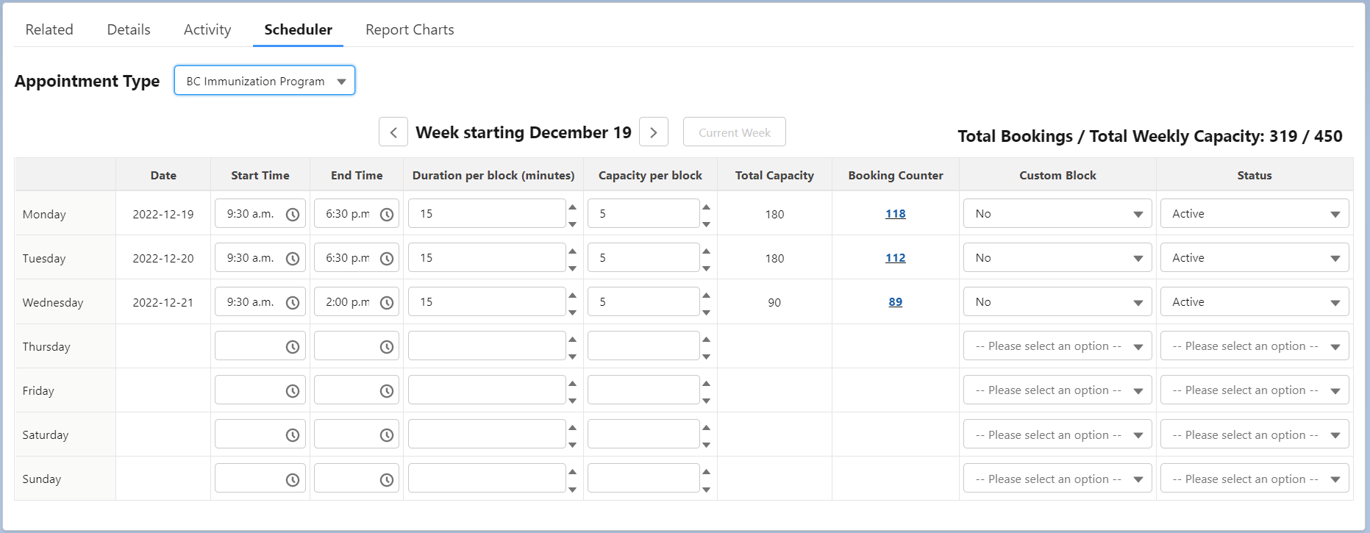
- Select the appointments that need to be cancelled by:
  - The filter function if appointments need to be cancelled within a specific time range;
  - Select all to cancel all appointments;
  - Or select appointments one by one.
- Click Cancel appointments to process the request. All clients will be notified via an automatic email that their appointment has been cancelled.
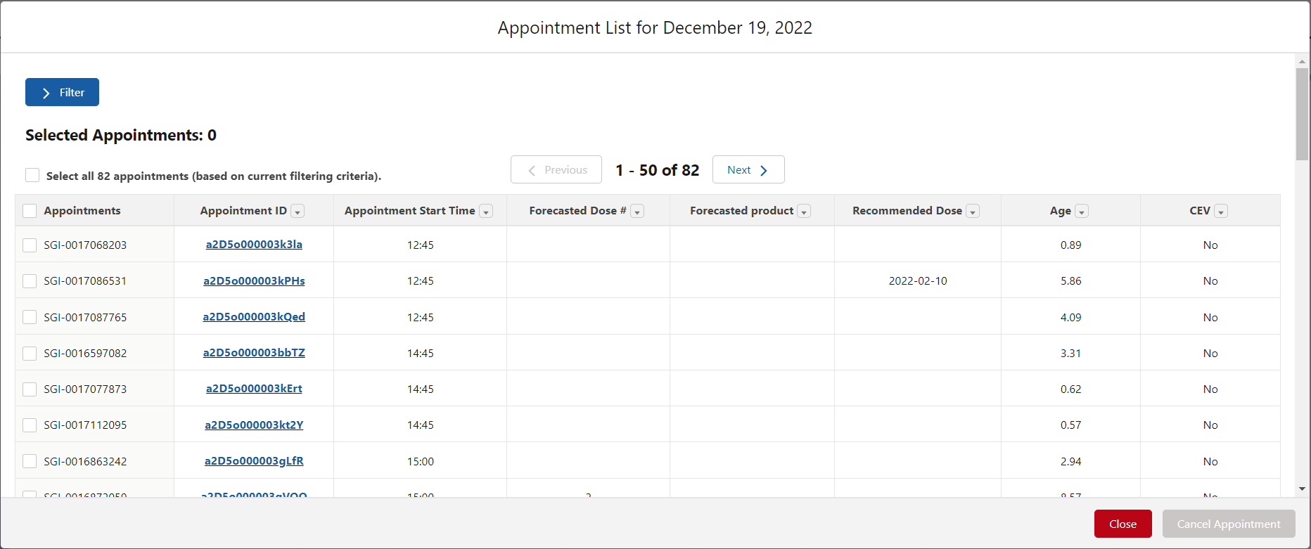
- Follow the process below to delete the clinic with no booked appointments.

With no booked appointments
In order to delete an appointment day, there can be no booked appointments for that particular day. This section is meant for appointments that were just created and that need to be deleted immediately due to an error.
To delete a recently created appointment day, follow these steps:
- Search for the clinic, and open the clinic tab
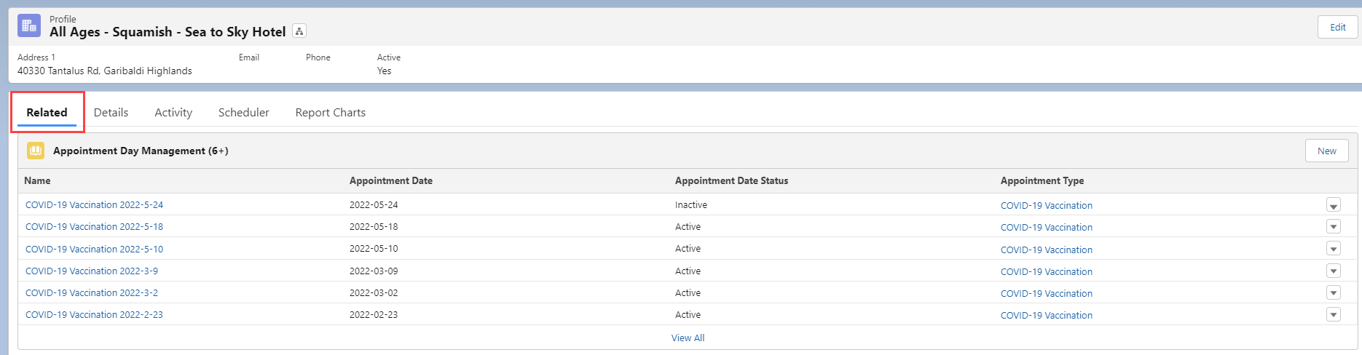
- On the Related tab, find the Appointment Day Management section.

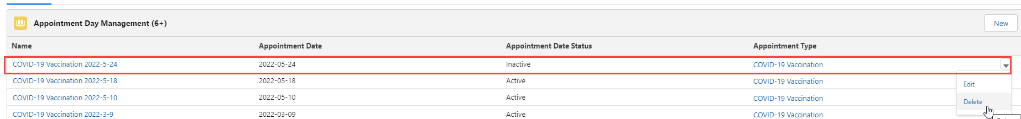
- Select the appointment day that needs to be deleted, click on the arrow (far right) and click on Delete
- Confirm that you want to delete the appointment day
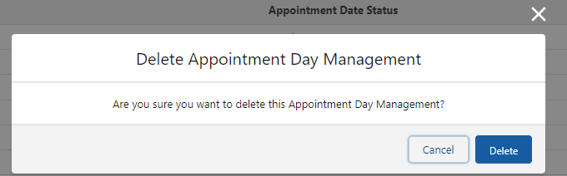

- Go back to scheduler to confirm that the appointments are deleted

Clinic Management

Creating New Clinics in ImmsBC
Contact Marianne.Santos@vch.ca for support.

Activate/Deactivate a clinic
If a clinic is not needed anymore, or it is for a future location, this feature enables to “hide” the clinic until it’s needed. Go to the clinic profile, click on the Details tab, then click in the button by the Active feature. Change to Yes/No depending on the case.
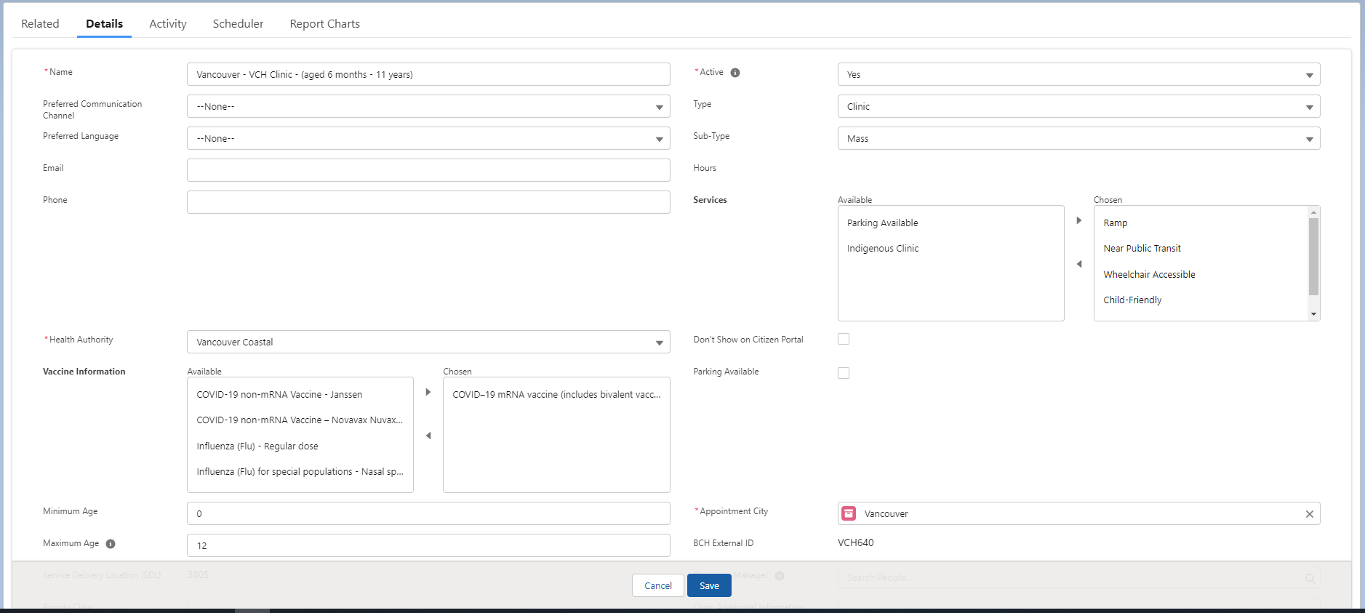

Don’t show on Citizen Portal
This feature can be used to keep a clinic active, but that’s it’s not available to see on the citizen’s portal. Click on to tick/untick this feature.

Add/Remove Clinic Attributes
Clinic attributes allow clients to filter locations by their preferred vaccine information and services on the citizen’s portal.
- To add an attribute, select one from the available list and click on the arrow to move the attribute from the available box to the chosen box.
- To remove an attribute, select one from the chosen list and click on the arrow to move the attribute from the chosen box to the available box.
The clinic must be active to save changes. If the clinic is not active and you wish to make the changes in advance:
- Mark the clinic as active, edit the attributes and save.
- Immediately after, change the clinic to inactive and save again.

Activate/Inactivate Supply Locations
If the clinic is active, ensure that the status of the supply location is set to active.
Go to the clinic profile, click on the Related tab, and then click the supply location name.
A new tab will open. Click in the button by the Active feature. Change the status to active or inactive and save.
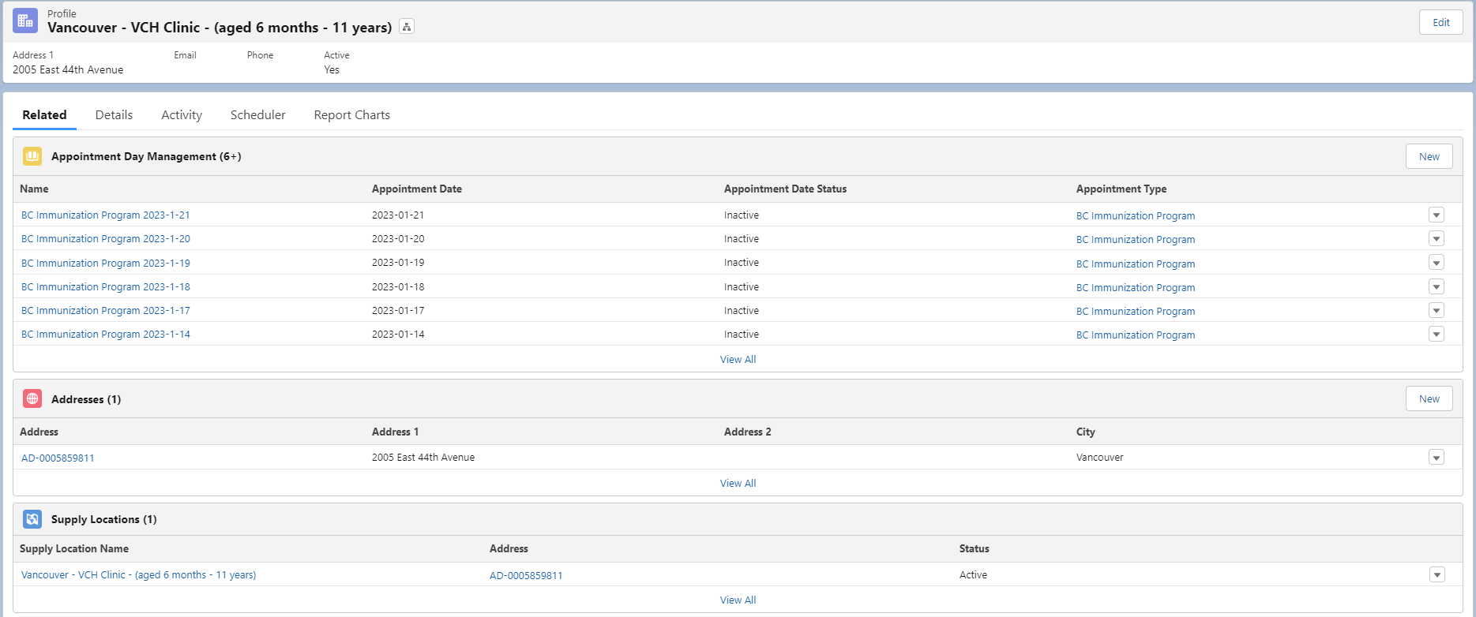
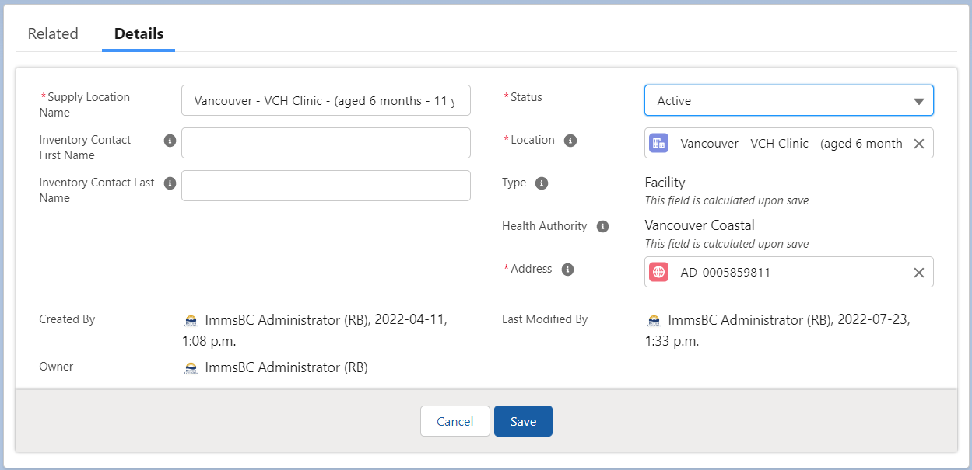

Support
ImmsBC User Help Zendesk
https://immsbc.zendesk.com/hc/en-ca
Provincial ImmsBC Command Centre (Mon-Fri 0800-1600)
Email: BCVAX-Support@gov.bc.ca
Zoom: https://zoom.us/j/93003034945?pwd=L3lkL0VqdEJvTjZ2cWMxelB3R3ppdz09
Meeting ID: 930 0303 4945
Passcode: 548989
Phone: +1 778 907 2071

